**PROJECT REPORT ON**

**COLLEGE CAMPUS SYSTEM**

**SRS DOUCUMENT**

INRTODUCTION

This Software Requirements Specification provides a description of all the functions and constraints of the Placement management System, developed for various colleges’ placement cell.

The Placement Management System is for the students and companies which maintains the database for the students where all the students’ records are entered including their academic details and their personal details. It will also manage the data of the Company which would comprise of the profile of the Company, eligibility criteria and the facilities or the package it provides etc.

PURPOSE

For the purpose of training and placement of the student in colleges, TPO’s have to collect the information and CV’s of students and manages them manually and arranges them according to various streams.

If any modification is required that is to be also done manually. So, to reduce the job required to manage CV’s and the information of various recruiters, a new system is proposed which is processed through computers.

SCOPE

The information of all the students can be stored. CV’s are categorized according to various streams. Various companies can access the information. Students can maintain their information and can update it. Notifications are sent to students about the companies. Students can access previous information about placement.

* Student Registration facility
* Student Login
* View Student Profile
* Company Page
* Company Login
* Company recruitment schedule Page
* View Recruitment Schedule
* View Selected List of Students
* Administrator Control Panel
* Updates by the Administrator
* View Updates by the Students

OBJECTIVE

Computer and information technology has a major influence on the society and the society is becoming more and more dependent on technology. Going on is an ear of simplifying almost all complicated works using computers. The last few years have witnessed a tremendous increase in the capabilities and use of computers. Manual processing makes the process slow and other problems such as inconsistency and ambiguilty on operation.

**FUNCTIONAL STUDY**

**FUNCTIONAL REQUIRMENT**

A student should be able to login to the system through the first page of the application, and mention his required user name and he should get his details which he can view and update it. An administrator can login into his account and he will update the student information.

**NON FUNCTIONAL REQUIRMENT**

***Usability***

* This section includes all of those requirements that effect usability.
* We get response with in a second.

***Reliability***

* The system is more reliable because of the qualities that are inherited from the chosen platform.

***Supportability***

* The system is designed to be the cross platform supportable. The system is supported on a wide range of hardware and any software platform.

***Implementation***

* The system is implemented in web environment.

**PERFOMANCE REQUIRMENT**

* The completely separate business logic at server side from the student interface ensures good performance.
* The system exhibits high performance because it is well optimized. The business logic is clearly separate from the User Interface.
* The response to the user is within seconds, providing all the information at a glance.

**ER-DIAGRAM**

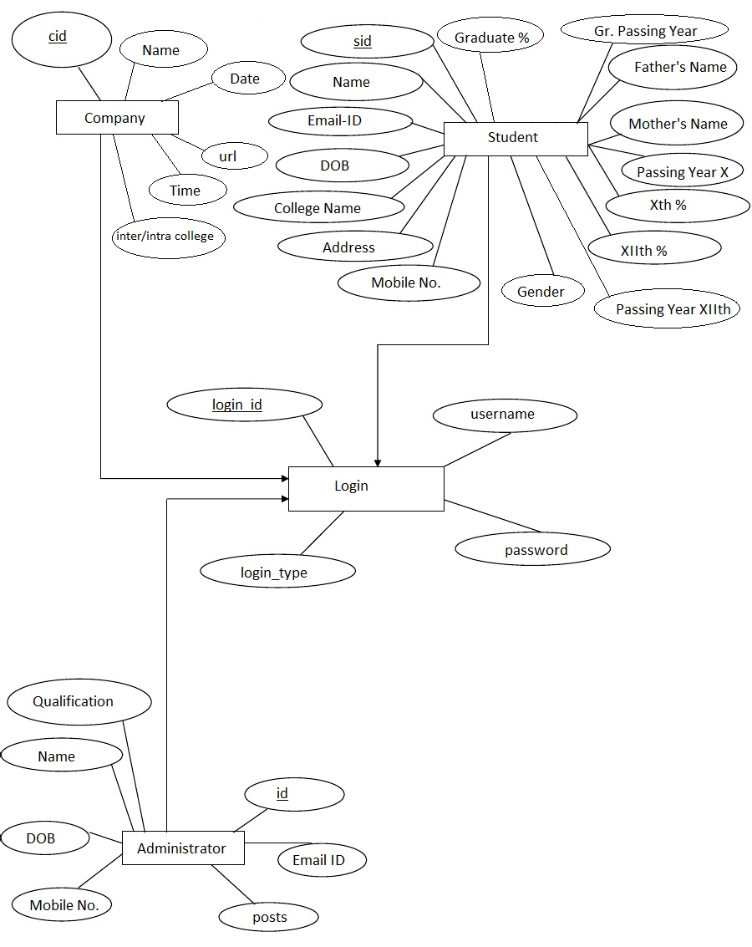

**DESIGN DOCUMENT**

TABLE NAME- ADMIN LOGIN

PK- User-ID

DESCRIPTION- Admin information

|  |  |  |  |  |
| --- | --- | --- | --- | --- |
| Field Name | Data Type | NULL? | KEY | Description |
| Sl_NO | INT | N |  | Serial No |
| User Name | VARCHAR(20) | N | Pk | User Name |
| User Password | VARCHAR(20) | N |  | User Password |

TABLE NAME- COMPANY LOGIN

PK- User-NAME

DESCRIPTION- Company information

|  |  |  |  |  |
| --- | --- | --- | --- | --- |
| Field Name | Data Type | NULL? | KEY | Description |
| Sl_NO | INT | N |  | Serial No |
| User Name | VARCHAR(20) | N | Pk | User Name |
| User Password | VARCHAR(20) | N |  | User Password |

TABLE NAME- STUDENT REGISTATION

PK- Student-id

DESCRIPTION- Student information

|  |  |  |  |  |
| --- | --- | --- | --- | --- |
| Field Name | Data Type | NULL? | KEY | Description |
| Sl_NO | INT | N |  | Serial No |
| Sid | VARCHAR(20) | N | Pk | Student -id |
| User Name | VARCHAR(20) | N |  | User Name |
| Gender | VARCHAR(20) | N |  | gender |
| DOB | DATETIME | N |  | Time |
| College Name | DATETIME | N |  | College name |
| Branch | VARCHAR(80) | N |  | Branch |
| Mobile | VARCHAR(20) | N |  | Mobile |
| E-Mail id | VARCHAR(20) | N |  | E-Mail id |
| Address | VARCHAR(20) | N |  | Address |
| Stream | VARCHAR(20) | N |  | Stream |
| Year of passing | INT | N |  | Year of passing |

TABLE NAME- CAMPUS REGISTATION

PK- User Name

DESCRIPTION- Campus information

|  |  |  |  |  |
| --- | --- | --- | --- | --- |
| Field Name | Data Type | NULL? | KEY | Description |
| Sl_NO | INT | N |  | Serial No |
| User Name | VARCHAR(20) | N | Pk | User Name |
| Password | VARCHAR(20) | N |  | User Password |
| Company Name | VARCHAR(20) | N |  | Company Name |
| Designation of Post | VARCHAR(20) | N |  | Designation of Post |
| No of Vacancies | INT | N |  | No of Vacancies |
| Eligibility Craitaria | VARCHAR(20) | N |  | Eligibility Craitaria |
| Service Agreement | VARCHAR(20) | N |  | Service Agreement |
| Salary | INT | N |  | Salary |

TABLE NAME- CAMPUS SCHEDULE

PK- User Name

DESCRIPTION- Campus Drive Schedule

|  |  |  |  |  |
| --- | --- | --- | --- | --- |
| Field Name | Data Type | NULL? | KEY | Description |
| Sl_NO | INT | N |  | Serial No |
| User Name | VARCHAR(20) | N | Pk | User Name |
| Company Name | VARCHAR(20) | N |  | User Password |
| Date | DATE | N |  | Date |
| Time | TIME | N |  | Time |
| Venue | VARCHAR(20) | N |  | Venue |

**PROGRAM SPECIFICATION**

**ADMIN LOGIN**

|  |  |
| --- | --- |
| **Screen Name** | Login |
| **Module** | Admin |
| **Menu Reference** | Login |
| **Dependency on Module** | NA |
| **Inputs** | |
| * User Name * Password | |
| **Validation** | |
| * Username should not blank. * Password should. * Invalid Username or password. * System locked for three wrong password entered. * Password should expire in 60 days * Password has expired ,change the password | |
| **Process Logic** | |
|  | |
| **Output** | |
| * Redirect to Company Login | |

**COMPANY LOGIN**

|  |  |
| --- | --- |
| **Screen Name** | Login |
| **Module** | Admin |
| **Menu Reference** | Login |
| **Dependency on Module** | NA |
| **Inputs** | |
| * User Name * Password | |
| **Validation** | |
| * Username should not blank. * Password should. * Invalid Username or password. * System locked for three wrong password entered. * Password should expire in 60 days * Password has expired ,change the password | |
| **Process Logic** | |
|  | |
| **Output** | |
| * Redirect to Student Registration | |

**STUDENT REGISTRATION**

|  |  |
| --- | --- |
| **Module** | Registration |
| **Menu Reference** |  |
| **Dependency on Module** | Login |
| **Inputs** | |
| * S.ID * User Name * Gender * Mobile * Email Id * DOB * College Name * Branch * Address * Stream * Year of Passing | |
| **Validation** | |
| * Username should not blank. * All fields are mandatory (*) * Could not save data at this time. * User already exist | |
| **Process Logic** | |
|  | |
| **Output** | |
| * Data save Successfully and redirect to Campus Registation. | |

**CAMPUS REGISTRATION**

|  |  |
| --- | --- |
| **Module** | Registration |
| **Menu Reference** |  |
| **Dependency on Module** | Login |
| **Inputs** | |
| * User Name * Password * Company Name * Designation of Post * No of Vacancies * Eligibility Criteria * Service Agreement * Salary | |
| **Validation** | |
| * Username should not blank. * All fields are mandatory (*) * Could not save data at this time. * User already exist | |
| **Process Logic** | |
|  | |
| **Output** | |
| * Data save Successfully and redirect to Campus Drive Schedule | |

**CAMPUS DRIVE SCHEDULE**

|  |  |
| --- | --- |
| **Module** | Campus Drive |
| **Menu Reference** |  |
| **Dependency on Module** | Login |
| **Inputs** | |
| * User Name * Company Name * Date * Time * Venue | |
| **Validation** | |
| * Username should not blank. * All fields are mandatory (*) * Could not save data at this time. * User already exist | |
| **Process Logic** | |
|  | |
| **Output** | |
| * Data save Successfully and redirect to Student Registation. | |

**TEST CASE**